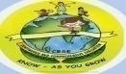
GREENWOOD PUBLIC SCHOOL, DD NAGAR, GWALIOR
OUR MOTTO- DEVELOPMENT WITH DELIGHT

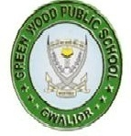
CLASS-1
Chapter 1
Subject – EVS

- Draw or paste your picture here.

- Complete these sentences about yourself.

- I am _________________. (name)
- I am a_____________. (boy or girl)
- I am _____________years old .(age)
- I live in____________(name of city or town)
- My favourite game is___________.
- My favourite colour is___________.
- My favourite food is_____________.

Chapter-2
My Body
Subject-Evs

- Your body has many parts. Let us look at these parts.

- Point to each part of our body and say:

- This is my head.
- This is my face.
- This is my neck.
- This is my shoulder.

- This is my hand .
- This is my chest.
- This is my stomach.
- This is my leg.
- This is my knee.
- This is my foot

- Fill in the blanks with words ‘one’ or ‘two’.one has been done for you.

- I have two eyes.
- I have ____ nose.
- I have ____ ears.
- I have_____ chin.
- I have ____ mouth.
- I have ____ lips.

